

GUIDELINE
Defect Management System

Code | 26e-HD/PM/HDCV/FSOFT
Issue/revision | 1/0
Effective date | 07/12/2006

Table of content
1 INTRODUCTION 5
1.1 Purpose 5
1.2 Application scope 5
1.3 Related documents 5
1.4 Abbreviations 5
2 DEFECT MANAGEMENT 6
2.1 Defect concepts 6
2.2 Life Cycle of a Defect 6
2.3 Defect Data 7
2.3.1 Summary of defect data 7
2.3.2 Defect data description 9
2.3.2.1 Project code 9
2.3.2.2 Project Status 10
2.3.2.3 Defect ID 11
2.3.2.4 Created User 11
2.3.2.5 Defect status 11
2.3.2.6 Title 13
2.3.2.7 Description 13
2.3.2.8 QC Activity 14
2.3.2.9 Type of Activity 16
2.3.2.10 Stage Detected 17
2.3.2.11 Work Product 17
2.3.2.12 Module Code 17
2.3.2.13 Assigned To 18
2.3.2.14 Corrective Action 18
2.3.2.15 Closed Date 19
2.3.2.16 Fixed Date 19
2.3.2.17 Created Date 19
2.3.2.18 Project Origin 20
2.3.2.19 Reference 20
2.3.2.20 Defect Origin 20
2.3.2.21 Stage Injected 23
2.3.2.22 Priority 24
2.3.2.23 Severity 24
2.3.2.24 Defect Type 25
2.3.2.25 Due Date 28
2.3.2.26 History 29
2.3.2.27 Attached files 29
3 DMS USING & MONITORING 30
3.1 Using DMS 30
3.1.1 Login 30
3.1.2 Log defects 30
3.1.3 Update defects 32
3.1.3.1 Update specific defect 32
3.1.3.2 Batch update 32
3.1.4 View defects 33
3.1.4.1 View details of a defect 34
3.1.4.2 View defect listing 34
3.1.4.3 Refreshing view 35
3.1.5 Export defects 36
3.1.6 Import defects 36
3.1.7 Move defects 37
3.1.8 DMS Help 38
3.1.9 Logout 38
3.2 Monitoring DMS 39
3.2.1 Assign User 39
3.2.2 Work Product 39
3.2.3 Module 39
3.2.4 Setup Environment 40
3.2.5 Manage Planned Defect 40
4 MEASUREMENTS 41
4.1 Defect summary 41
4.1.1 All 41
4.1.2 Defect Tracking 42
4.1.3 Defect Leakage 42
4.1.4 Defect Type 42
4.1.5 Defect Distribution 42
4.1.6 Defect Summary 43
4.2 Defect related metrics 43
5 Appendix A – Defect logging for test projects 46

INTRODUCTION

Purpose
The goal of this document is to guide project team in understanding of defect information, logging, monitoring and measuring defects using Defect Management System.
Test activities in software projects are typically performed by Test team of projects.

Application scope
This document is applied for FSoft software projects.

Related documents

No | Code | Name of documents
 | 07e-HD/PM/HDCV/FSOFT | Guideline_Test
 | 08e-HD/PM/HDCV/FSOFT | Guideline_Software metrics
 | 08e-BM/PM/HDCV/FSOFT | Template_Project database

Abbreviations

Abbreviations | Expansion | Note
DMS | Defect Management System
PQA | Process Quality Assurance
QC | Quality Control
SQA | Software Quality Assurance
Wdef | Weighted defect
UCP | Use-case point | To measure project size

DEFECT MANAGEMENT

Defect concepts
A defect is any error found by testing and reviewing activities (All errors found by internal reviewer, external reviewer and customer).
If you consider fixing regarding any recommendation, this recommendation should be logged as a defect in DMS, too.

Life Cycle of a Defect
- A defect is found and must be recorded in DMS by a submitter (typically reviewer or tester). The defect is logged in DMS with defect status “Error” and other information.
- Project Leader has to review data of a defect (defect type, origin, severity, etc.):
    - If it is confirmed as defect, assign appropriate person to fix the defect. Generally assigned member is also the author of the document or code in which the defect has been found. The defect status is changed to “Assigned”.
    - If the defect can be accepted (by customer) without any corrective action, Project Leader needs to change the defect status to “Accepted”.
    - If the defect is logged inappropriately (in some situations defined in Section 2.3.2.5), Project Leader will cancel the defect by changing its defect status to “Cancelled”.
- After fixing the defect, the assigned person changes the defect’s status to “Pending”.
- Tester or project leader re-tests pending defect and updates defect status to “Tested” if the bug is fixed successfully, otherwise to “Error”.
The life cycle of a defect is modeled in below flow chart (the arrows indicate defect status changes):
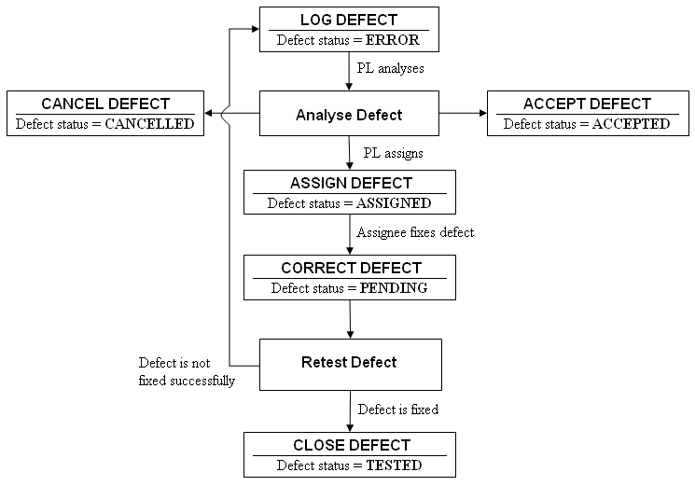
Figure 1. Defect Management Process

Defect Data

Summary of defect data
The following table lists information that a defect contains:
(A = auto-generated, M = Mandatory, O = Optional)
# | Data | Description of the Data | M/A/O
1 | Project code | Code of the project in which the defect occurs | M
2 | Project Status | Indicate status of current project | M
3 | Defect ID | This is ID of the defect. This number is automatically generated whenever a new defect is added. Defect ID counter will not be reset. | M/A
4 | Created User | Person who logged the defect, generally the person who found the defect such as tester or reviewer. This field cannot be changed. | M/A
5 | Defect Status | Current status of the defect | M
6 | Title | A short & brief description of the defect for quick recognition. | M
7 | Description | Full description of the defect, often the steps to reproduce the defect. | M
8 | QC Activity | The QC activity in which the defect is found | M
9 | Type of Activity | The type of QC activity, automatically generated when QC Activity is selected | M
10 | Stage Detected | Stage of project defined life cycle in which the defect is found | O
11 | Work Product | Work product in which the defect is found. It is high level CI. | M
12 | Module Code | Module of work product in which the defect is found. Module is often a CI. | O
13 | Assigned To | Person who has responsibility to correct the defect, typically the author | O
14 | Corrective Action | Actions/steps to correct the defect | O
15 | Closed Date | Date on which the defect is closed. It is automatically filled with current date when defect status is changed to Tested. | M/A
16 | Fixed Date | Date on which the defect is fixed | O/A
17 | Created Date | Date on which the defect is found | M/A
18 | Project Origin | Project that the defect actually belongs to, may be previous project | O
19 | Reference | Reference document of the defect if any | O
20 | Defect Origin | Software process in which the defect is caused | M
21 | Stage Injected | Stage of project defined life cycle in which the defect is caused | O
22 | Priority | How urgent the defect needs to be fixed | M
23 | Severity | How serious the defect will affect on software program | M
24 | Defect Type | Classification of the defect | M
25 | Due Date | Date on which the defect should be fixed | O/A
26 | History | Tracking the status changes of defect. It includes the date and person who has changed status of defect. The history is automatically generated and cannot be changed. | A
27 | Attached files | Extra files that come with the defect may be an image for illustration or source code file. User can attach 04 files with maximum 256Kb/file. | O

Defect data description

Project code
This information indicates which project the defect belongs to. Often it is automatically generated when choosing appropriate project before logging the defect.
Project code can be selected from a combo box as in the following illustration:
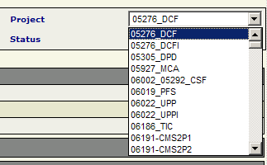
The combo box will be disabled during new defect creation, so user needs to choose appropriate project before logging.
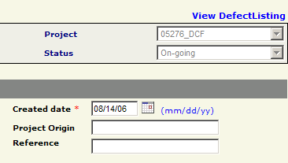

Project Status
Project status field indicates status of current project and provides a filter to list only projects with specific status for easy management.
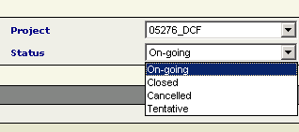

There are 04 different statuses that a project may have:

# | Project Status | Explanation
1 | On-going | Projects that are running (not finished)
2 | Closed | Projects that are finished
3 | Cancelled | Projects that are cancelled for some reasons (no longer running)
4 | Tentative | Projects that are going to be opened soon (may be running or not ready yet)

Defect ID
This is an automatically generated field. User cannot change Defect ID.
Defect ID will increase one-by-one as defects are logged to DMS.
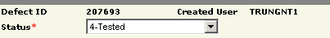

Created User
This field is automatically generated. Whoever logins to DMS and create a new defect will have his/her account name attached to the defect as Created User.
This field cannot be changed after logging.
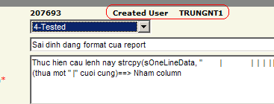

Defect status
There are 06 different statuses a defect may have (refer to Section 2.2 for defect life cycle)

# | Defect Status | When | Doer
1 | Error | First creation of a defect | All
1 | Error | Defect is not successfully fixed | Project leader  Tester/SQA
2 | Assigned | Log defect and choose Assigned To | All
2 | Assigned | PL assigns defects with status 1-Error to a member to fix | Project leader
2 | Assigned | Re-assign when bug fix is not complete | Project leader  Tester/SQA
2 | Assigned | Re-assign to another person | Project leader  Assigned person
3 | Pending | After defect is fixed & waits to be re-tested | Assigned person
4 | Tested | After defect is fixed & verified successfully | Project leader  Tester/SQA
5 | Accepted | Customer accepted that the defects need not to be fixed | Project leader
5 | Accepted | Project leader decides that the defect is too minor or too difficult to fix (great effect on effort, schedule, budget, etc.) and negotiates with customer about status | Project leader
6 | Cancelled | Incorrectly logging (not a bug) | Project leader  Tester/SQA
6 | Cancelled | Duplicate defects | Project leader  Tester/SQA
6 | Cancelled | Defects become change requests (customer requests to extend functionalities & PL must confirm with SQA, etc.) | Project leader  Tester/SQA
6 | Cancelled | Defects belong to customer module/software, extra tools (not developed by team members) | Project leader  Tester/SQA
6 | Cancelled | Defects that customer requests to move to next phase/project (confirm with SQA & make hints to filter later) | Project leader  Tester/SQA
6 | Cancelled | Defects are automatically removed because another defect is fixed | Project leader  Tester/SQA
Notes:
+ Defect status combo box is only visible when modifying a defect, not when the defect is created.
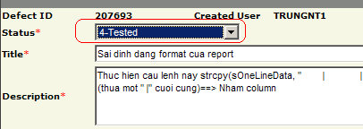
+ Before canceling a defect, it is necessary to confirm with creator (Created User).
+ All cancelled defects should come with explanation in Corrective action.
+ Defects to be considered Accepted must come with evidence taken from customer.

Title
This is a brief description about defect. Title may include extra information for easy filter (including module name, class name, product name, section/item/screen/feature, etc. for easy tracking). Max length of this field is 150 characters.

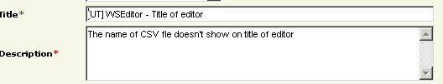
Notes:
User should include some more information in Title for easier searching later.
For example: add [CR] or [Change Request] to defect title to be able to list only defects that become change requests in a project.

Description
This is full description of a defect; often it describes steps to reproduce a defect. Max length of this field is 1200 characters.
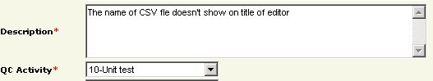

User may use the following suggestion for a good description:
+ For documents: Maybe either of the following
- Copy inferior part of documents
- Brief description about errors
+ For coding:
- Copy infected lines of code with short introduction about why it comes to error.
+ For testing:
- All necessary information to make defect reproducible (pre-condition, test data and test scripts to be used, detailed steps/procedures and corresponding results).

QC Activity
There are 02 main types of QC activities: review & test. These QC Activities are related to software development process.
There are also 02 other QC activities that relate to inspection & audit activities done by SQA & PQA.
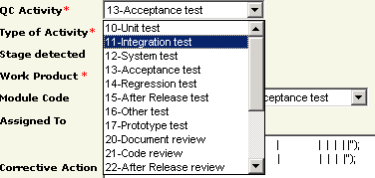

# | QC Activity | When | Doer
1 | Unit test | For unit testing | Developer
2 | Integration test | For integration testing | Tester  Developer
3 | System test | For system testing | Tester
4 | Acceptance test | For acceptance testing (after releasing source code to customer) | Project leader  Tester
5 | Regression test | For regression testing activities (test from the 2nd time) | Tester
6 | After release test | For testing activities that are taken after releasing software package | Project leader  Tester
7 | Other test | For testing activities that cannot be classified into the above review activities | Project leader  Developer  Tester
8 | Prototype test | For testing either requirement prototype or design prototype | Developer
9 | Document review | For reviewing SRS, design documents (HLD, LLD), Test plan, Test cases, Test report and other documents (technical or planning) | Project leader  Developer  Tester  SQA (PQA)
10 | Code review | For reviewing code | Project leader  Developer
11 | After release review | For reviewing activities that are taken after releasing documents or source code | Project leader  Tester
12 | Prototype review | For reviewing either requirement prototype or design prototype | Project leader  Developer
13 | Other review | For reviewing activities that cannot be classified into the other review activities | Project leader  Developer  Tester  SQA (PQA)
14 | Quality gate inspection | Quality gate inspection by PQA at each milestone | SQA (PQA)
15 | Final inspection | Final inspection taken by SQA before any delivery of products to customer | SQA
16 | Other inspection | Inspection activities that cannot be classified into other inspection types | SQA (PQA)
17 | Baseline audit | Baseline audit taken by SQA | SQA
18 | Other audit | Audit activities that cannot be classified into other audit types | SQA (PQA)

Notes:
There’s no PQA role in DMS, so PQA uses the same role as SQA.
External reviewers often use the role of developer, depending on PL assignment.
Defect with QC Activity = After release review, After release test & Acceptance test are counted to be leakage of a project.

Type of Activity
Activity Type is a mandatory field and relates to QC Activity. When you choose a QC Activity, Type of Activity will be automatically set to corresponding value.
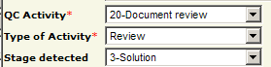
Currently there’s only one Activity Type attaches to each range of QC Activity as shown on the following table:

# | QC Activity | Type of Activity
1 | Baseline audit  Other audit | Audit
2 | Document review  Code review  After release review  Prototype review  Other review | Review
3 | Unit test  Integration test  System test  Acceptance test  Regression test  After release test  Other test  Prototype test | Test
4 | Quality gate inspection  Final inspection  Other inspection | Inspection

Stage Detected
This field indicates stage of project defined life cycle in which the defect is found. The available stages are defined based on type of project life cycle (development, maintenance, etc.)
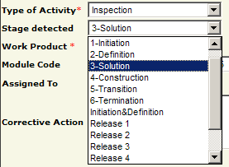

Work Product
Work Product is a mandatory field for defect classification by high level CI. It groups all CIs of the same type into one by defining CIs (products) in Fsoft Insight.
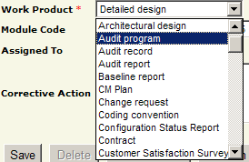

Module Code
List of modules is changed whenever user changes Work Product field. Each work product comes with a number of module codes.
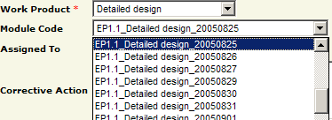
Modules are similar to CIs (products) and modules are defined in Fsoft Insight before they can appear in DMS.
Notes: User should select Module Code when logging defects because it helps to ease analysis of defect status later.

Assigned To
This field indicates who will be responsible for fixing the defect. PL will choose one person from the list of team members in the combo box to fix the defect after analyzing.
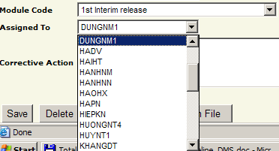

Corrective Action
This field is used to determine how defects are fixed. For better Corrective Action, it is suggested that assigned person adds the following information whenever changing defect status to Pending:
+ For documents: Briefly describe how you fix the defects
+ For coding/testing: Describe how you fix the defects & copy lines of code for reference
+ For canceling defects: reason why, often including reference to evidence documents (customer mails).
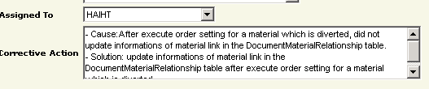
Notes:
This field should be filled when Defect Status is Pending, Tested, Accepted or Cancelled.

Closed Date
This field indicates which date the defect was confirmed to be successfully fixed. It’s automatically generated whenever user changes Defect Status to Tested.
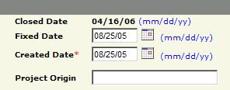

Fixed Date
This field does not appear on new defect creation screen, but on existing defect modification screen. This field is used to track defect removal progress. Often it is automatically filled by DMS when user changes Defect Status to Pending.
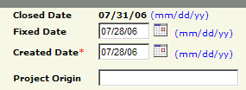
This field can be changed later.

Created Date
This field is mandatory – it must be the date on which the defect was actually found.
However, this field is automatically generated whenever user adds a new defect. Default value is the date on which defect is logged, so user needs to change it to the actual found date if user imports or adds the defect long after its occurrence.
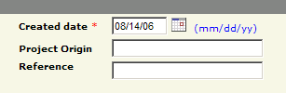

Project Origin
This field indicates from which project the defect actually belongs to.
It is often used in project that lasts for many phases. The defect may belong to previous phase but is discovered in the current phase. The defect will be logged in defect database of current phase but with Project Origin = code of previous phase.
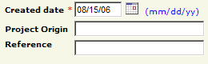

Reference
This is an optional field. Project may consider using this field to refer to defect-related document or may use it as a filter for defect.
For example:
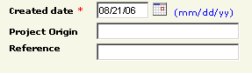

Defect Origin
Defect Origin indicates the actual process that caused the defect.
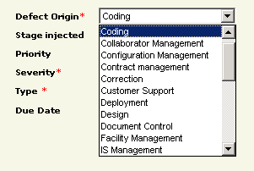
Defect origins are listed in the following table:

# | Defect Origin | Description
1 | Administration | Defects originate from activities that relate to Administration process.
2 | Coding | Defects originate from either of the following activities:  - Code review  - Unit testing activities (related to program bugs)  - Integration testing activities (related to program bugs)  - System testing activities (related to program bugs)  - Regression testing activities (related to program bugs)  - Acceptance testing activities (related to program bugs)
3 | Collaborator Management | Defects originate from activities that relate to Collaborator Management process.
4 | Configuration Management | Defects originate from activities that relate to Configuration Management process.  Examples: Defects from reviewing CM Plan, setting CM environments, etc.
5 | Contract Management | Defects originate from activities that relate to Contract Management process.
6 | Correction | Defects originate from activities that relate to Correction process.
7 | Customer Support | Defects originate from activities that relate to Customer Support process.
8 | Deployment | Defects originate from activities that relate to Deployment process.
9 | Design | Defects occur in design documents, either ADD or HLD or DDD (LLD), mainly focus on logic of these documents.  Defects come from reviewing or testing design documents/prototype or while reviewing code or test cases, found design errors.
10 | Document Control | Defects occur in documents (SRS, design documents, test plan, test cases, test report, etc.). Mainly these defects are about template, formatting, versioning (newest from QMS & wrong version increment), etc.
11 | Facility Management | Defects originate from activities that relate to Facility Management process.
12 | IS Management | Defects originate from activities that relate to IS Management process.
13 | Internal Audit | Defects originate from activities that relate to Internal Audit process. These defects are called NCs. However, they are now logged to NCMS instead of DMS.
14 | Management Review | Defects originate from activities that relate to Management Review process.
15 | Other | Defects that appear to be unable to map with any other process.
16 | Prevention | Defects originate from activities that relate to Prevention process.
17 | Process Improvement | Defects originate from activities that relate to Process Improvement process.
18 | Project Management | Defects originate from activities that relate to Project Management process.
19 | Quality Control | Defects originate from activities that relate to Quality Control process.
20 | Quality Planning | Defects originate from activities that relate to Quality Planning process.
21 | Recruitment | Defects originate from activities that relate to Recruitment process.
22 | Requirement | Defects occur in requirement documents, either URD, SRS, mainly focus on logic of these documents.  Defects come from reviewing or testing requirement documents/prototype or while reviewing design, code or test cases, found requirement errors.
23 | Retirement | Defects originate from activities that relate to Retirement process.
24 | Staff Management | Defects originate from activities that relate to Staff Management process.
25 | Student Management | Defects originate from activities that relate to Student Management process.
26 | Subcontract Management | Defects originate from activities that relate to Subcontract Management process.
27 | Technology Management | Defects originate from activities that relate to Technology Management process.
28 | Test | Defects occur in test documents or testing activities (lack of test cases, tester misunderstands specs, tester does not follow test cases, incorrect test data creation, bugs in test scripts, etc.)
29 | Training | Defects originate from activities that relate to Training process.

Stage Injected
This field indicates stage of project defined life cycle in which the defect is caused. The available stages are defined based on type of project life cycle (development, maintenance, etc.).
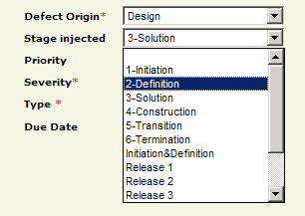

Priority
There are 04 priorities, depending on how urgent you rate the defect (need to fix early or may be fixed later).

# | Priority | Description
1 | Immediately | Defect should be fixed right away or within 01 day after logging
2 | High | Defect should be considered fixing within 02 - 04 days after logging
3 | Normal | Defect should be considered fixing within 05 - 08 days after logging
4 | Low | Defect can be delayed (to be fixed later when appropriate)

Severity
There are 04 severities available for a defect:
# | Severity | Description | Weight | Example
1 | Fatal | - A major issue where a large piece of functionality or major system component is completely broken.  - There is no workaround and testing cannot continue. | 10 | - The system/ application crashes permanently.  - Irrecoverable database corruption.
2 | Serious | - Major function or system component does not work, work incorrectly or is documented incorrectly.  - Security problem is assigned depending on priority of functions in the project. | 5 | - Security: users belong role A can see/perform functions (menu item) of role B, etc.
3 | Medium | Minor function does not work or works incorrectly or is documented incorrectly. | 3 | - Any special cases included invalid data, boundary value, etc. for major function returns incorrectly.  - Redundant outputs  - Performance effects
4 | Cosmetic | Very minor defects, no way to affect the functionalities of the product. | 1 | - Typing mistakes  - A spelling/grammatical error on a GUI screen/message.  - Align text, fields, forms, labels.  - Incorrect Tab index, set default button, set default cursor, short key, etc.  - Coding standard: name of object, variables, comments, etc.

Defect Type
This field is used to group defects by classifying types of problem. Defect Type is mandatory.
# | Type | Description | Example
1 | Requirement misunderstanding | Defects caused by misunderstanding between the whole team and customer.  Often relate to design, coding & test process. May be discovered by developers or testers. | Example 1:  Customer request: C = A + ABS(B) but developer does C = A + B  Example 2:  Requirement: Year field accepts value from 1990 to 2020.  Dev: Year field accept any number value.
2 | Feature missing | Lack of any feature or feature incomplete.  Often relate to design, coding & test process. | Customer requests 3 functions: Add new, modify and delete user but developer does only 2 functions: Add new and delete user.
3 | Business logic | Defects caused by misunderstanding between team members are classified.  Redundant functions cause business logic defects.  Requirements not clarified in requirement docs, assumptions of project team do not meet customer expectation, should correct.  Often relate to coding & test process. May be found by developers or testers. | In a system:  Page 1: When user click “Back” button, system displays previous page with status the same user has been done before.  Page 2: The “Back” button system displays previous page but the previous status the same user has been done before was refreshed.
4 | Coding logic | Carelessness  Technical skill  Data validation  Coding problems  Often relate to design (sample code) & coding process. May be discovered by developers or testers. | For component ListView in VB, ListItem is indexed from 1...n (n = Number of ListItem in ListView).  If developer indexes in code: for i = 0 to n-1 ==> The index n is missed, should start with 1.  It’s Coding logic defect: "Index of out bound".
5 | User Interface | Errors in Interface, Layout, Browsers (different browsers), etc.  Often relate to design (screen design) & coding process. May be discovered by developers or testers. | A spelling/ grammatical error on screen/ message.  Align text, fields, forms, labels.  Incorrect Tab index, set default button, set default cursor, short key, etc.
6 | Performance | Poor processing speed.  System crash because of load or memory problems.  The problems happen frequently to many users.  Often relate to coding (unit test) & test process.
7 | Design issue | Specific design-related matters.  Often relate to design process, may leak to coding or test later.
8 | Coding standard | Problems with coding standards: alignment, layout, comments, modification history.  Not follow coding convention.  Often relate to design & coding process. Found by review (manually or by tools).
9 | Document | Defects found while reviewing documents: Project Plan, SRS, Test Plan, etc. related to document standard (template, version, header/footer, etc.).  Grammar errors.  Relate to any process (requirement, design, coding or test), related to document.
10 | Data and Database Integrity | Problems with data handling or data flow; input/output.  Often relate to design (potential), coding or test process. | Deleting value from a table but forget to delete associated files on server or related records in other tables.
11 | Security and Access Control | Problems with security, user privilege.  Often relate to design (potential), coding or test process. | User types direct URL into address bar with parameters and is able to access specific page.
12 | Portability | Code not independent of the platform.  Often relate to design (potential), coding or test process. | Example 1:  Requirement said program can run on Windows & Linux but only on Windows it can run.  Example 2:  Web application does not work correctly on Netscape Navigator 4.78 but it works well on Internet Explorer 5.0
13 | Tool | Defect is caused by using tool.  Often relate to coding or test process. | Developers use tool to do unit test but tool reports incorrect results.
14 | Other | Not in any of the other types.

Due Date
This is the date on which the defect should be fixed. This field is automatically generated when a defect is submitted and default value is Created Date + 01 days.
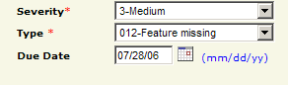
This field can be changed later.

History
History is used to track status changes of a defect. It includes the date and person who has changed status of defect. The history is automatically generated and will not be reset.
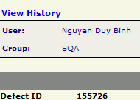

This is example of a defect history:
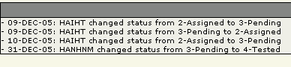

Attached files
This function is used to attach extra 1 - 4 files to defect for references. Maximum size for each file is 256Kb.
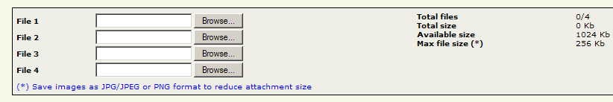
Files can be any of the following types:
+ Screen capture of errors
+ Infected code parts & fixed ones

DMS USING & MONITORING

Using DMS

Login
In order to use DMS system, user must enter a username & password to login.
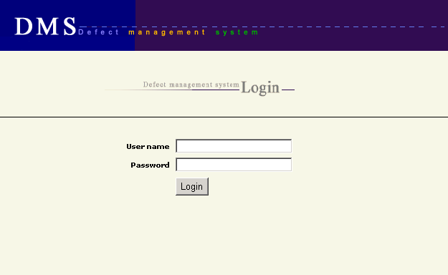

Notes:
Password to access DMS is different from password user uses to gain access to computer, network but is similar to password to access Timesheet, Fsoft Insight, etc.

Log defects
A defect can be created using either of the following methods:
+ Choose New Defect from DMS menu:

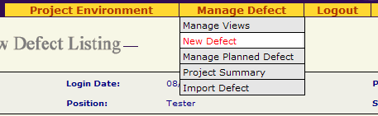

+ Use Add New button from defect listing view:
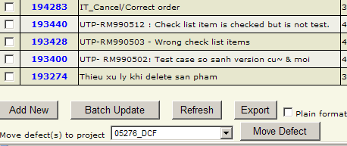

A screen will be displayed for user to type in necessary information of a defect.
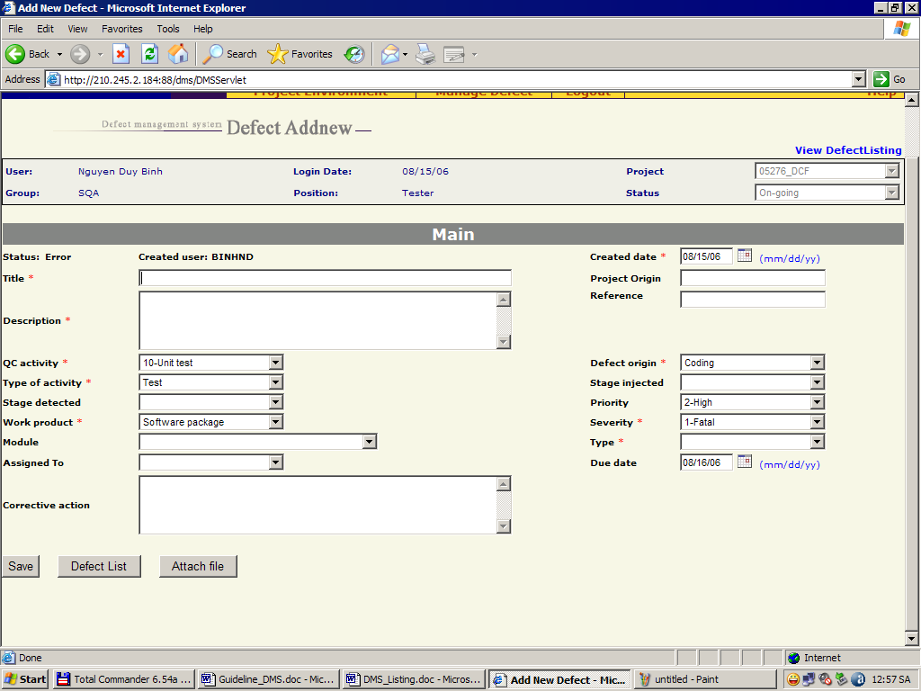

Update defects
There are 02 kinds of defect update:

Update specific defect
User chooses any defect from defect listing view for update by clicking on the Defect ID, which is a link actually.
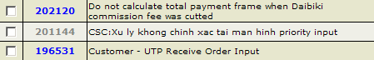

A screen with information of selected defect will be displayed for update.
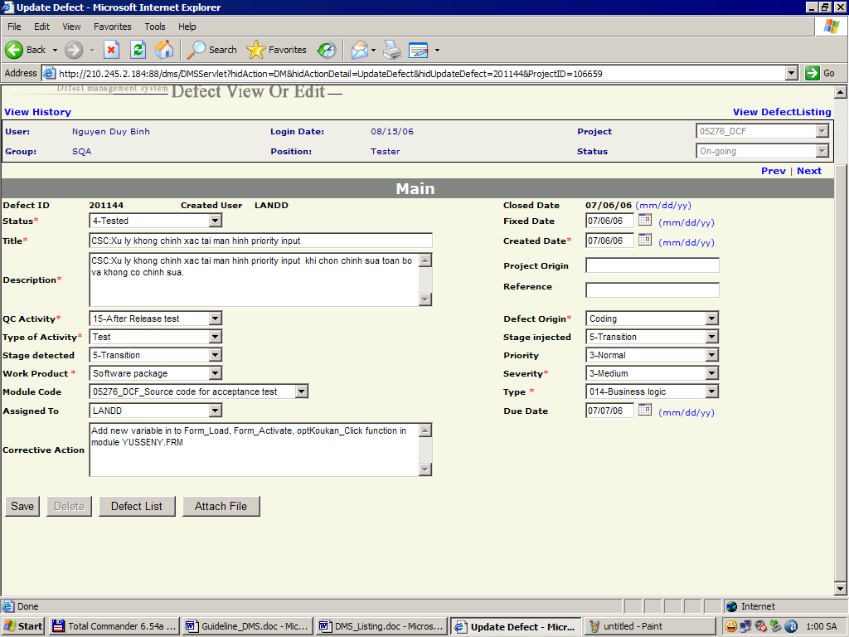

Batch update
User must select defects before using Batch Update. This function is available to all DMS users.
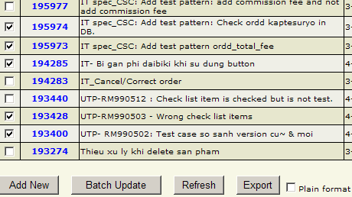

However, only specific information of defects can be updated via Batch Update.
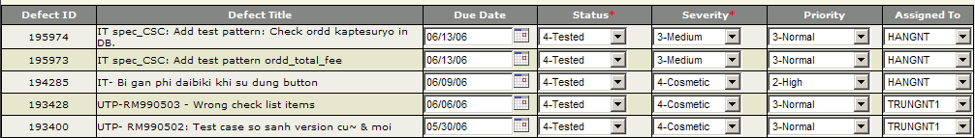

View defects
Defects can be view in various ways.

View details of a defect
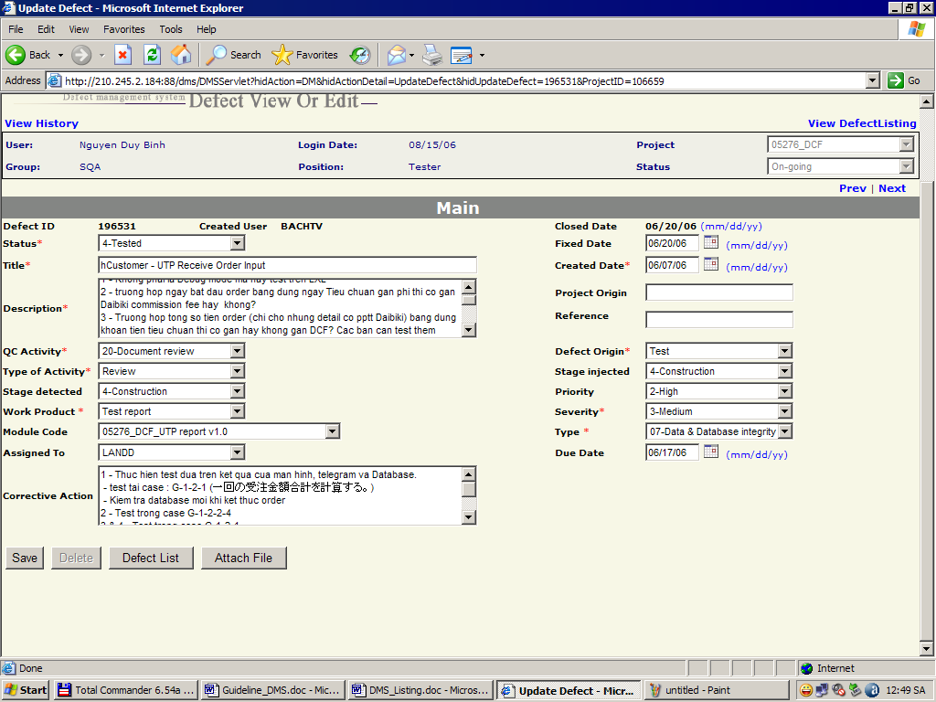

View defect listing
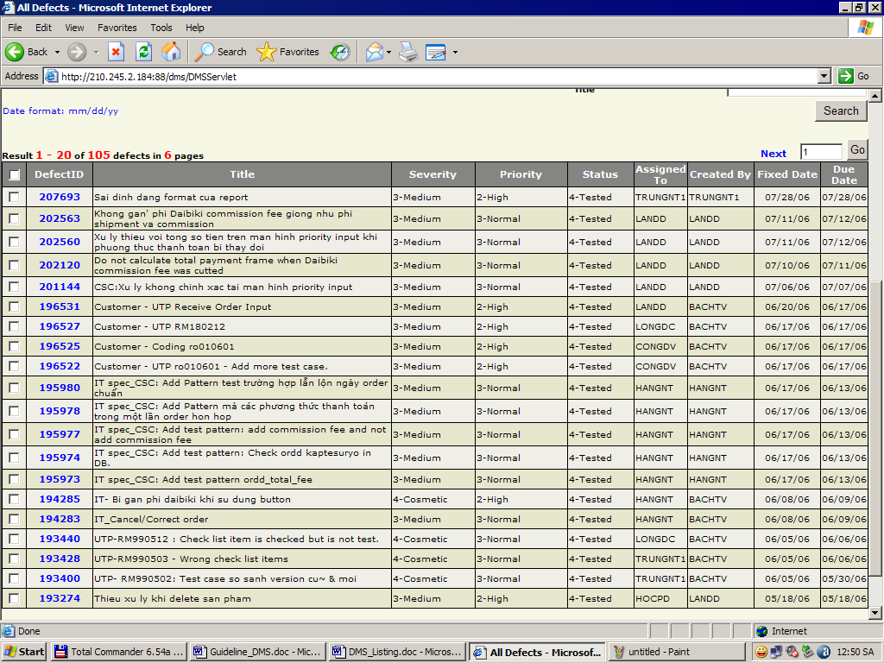

Number of defects in defect listing view can be controlled using any of the following methods:
          - Use filters
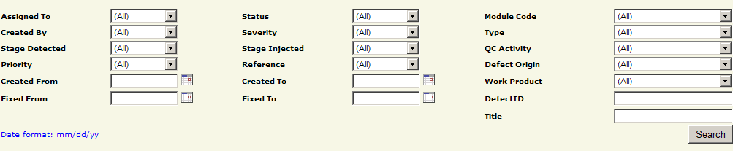

          - Use fixed queries
These queries are available as default for every project.
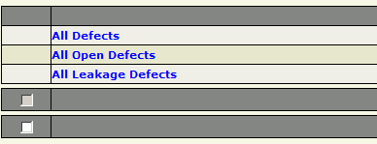

          - Use public/private query
These queries are created by DMS user to fit specific need.
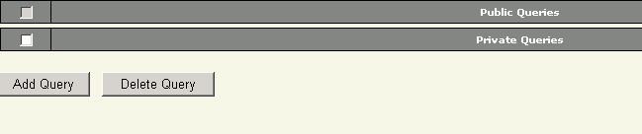
Only project leader can create Public queries. For PLs, query creation screen will display one more checkbox:

Refreshing view
Refresh button is used to update defect listing view to reflect latest changes in defect database of a project.
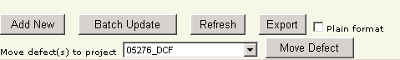

Export defects
This function can be done by any member of a project who can access defect database of that project.
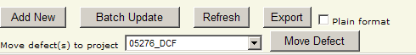
User must select defects first before exporting. Results will be a Microsoft Excel file with almost information about the defects of project.
Notes:
Choose plain format for better Microsoft Excel file (each defect on 01 row).
Number of defects exported depends on which query user currently uses. Only filtered defects are exported.
For example: If user choose different filter as shown below, number of exported defects will vary depending on type of query user has chosen.
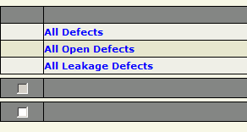

Import defects
This task can be done by anyone who can access to defect database of a project. Import function can be accessed from the DMS menu.
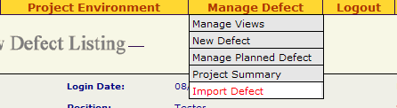
In order to import defects, user must:
+ Download defect import template from import page
+ Fill in appropriate information
+ Use Browse button to select file to import
+ Click Import button

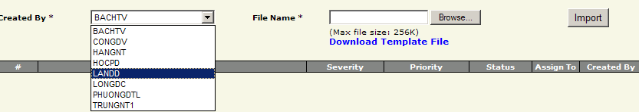

Note:
Imported defects will always have Defect Status equal to Assigned.
Currently, user can import only 20 defects at a time.
Template of exported defect list cannot be used for defect import.

Move defects
This task only can be done by SQA of a project. For users who are not SQA, this function will be disabled.
In order to move defects:
+ Choose defects from defect list
+ Choose a destination project from combo box
+ Click Move Defect button to move defects from current project to destination project.

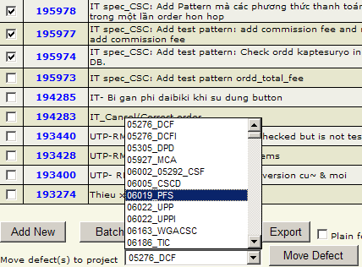

DMS Help
DMS Help link provides a quick guide to user on how to use DMS to manage defects. The link can be found at top-right corner of DMS screen.
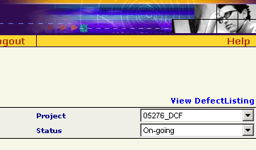

Logout
User should logout after he/she finishes working with DMS. Logout link can be found on DMS menu.
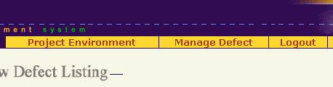

Monitoring DMS
All functions for DMS monitoring can be accessed from DMS menu.
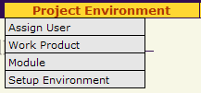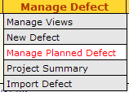

Assign User
This task only can be done by Project Leader of a project.
Project Leader will use this function to add users to use DMS for project defect database access. Being a project team member does not mean user can access DMS. Access right must be set manually.
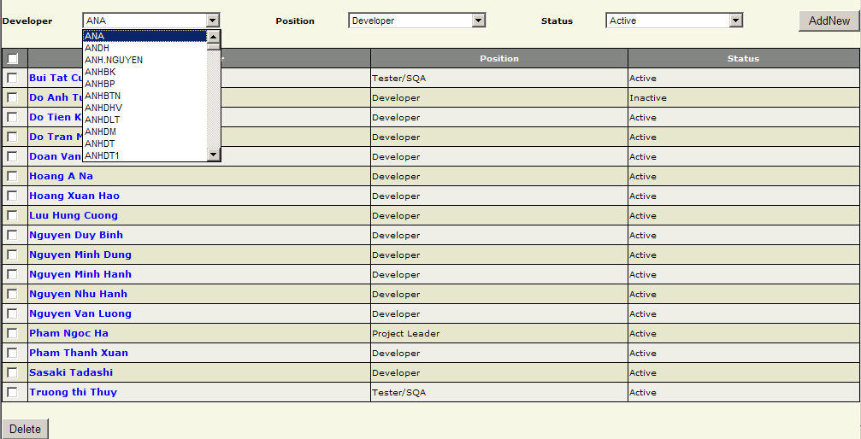

Work Product
This task only can be done by Project Leader of a project. However this function is deprecated and moved to Fsoft Insight.

Module
This task only can be done by Project Leader of a project. However this function is deprecated and moved to Fsoft Insight.

Setup Environment
This task only can be done by SQA of a project.
There are a number of environment features that SQA can change:
SQA can use this function to define specific or more values of combo boxes for selection. In the following example, SQA will add one more Severity to existing list:
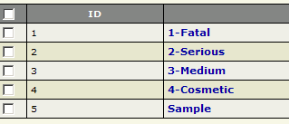

The newly added item will display in combo box of Severity:
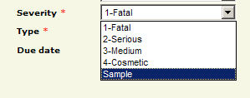
Although this function is available to SQA, it is suggested that this function should not be used by junior SQAs for it may cause inconsistency in defect database of project if incorrectly used.

Manage Planned Defect
This task only can be done by Project Leader of a project. However this function is deprecated and moved to Fsoft Insight.

MEASUREMENTS

Defect summary
Defect Summary can be accessed from DMS menu. This function provides summary of defects based on different criteria, thus allows DMS users to understand and track current status of defects in a project.
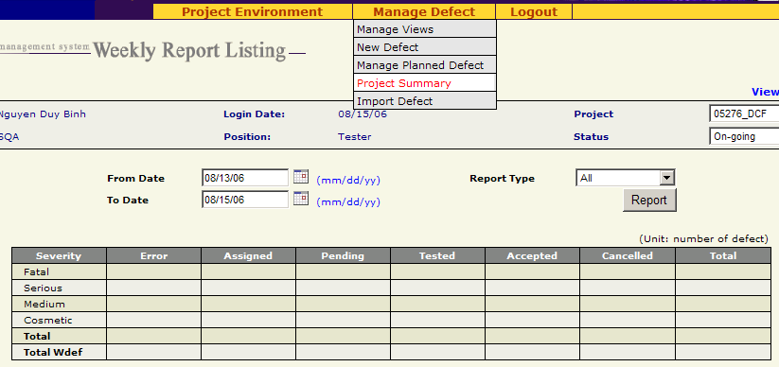
There are several types of report:
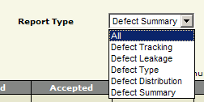

All
View defect summary by Severity & Defect Status
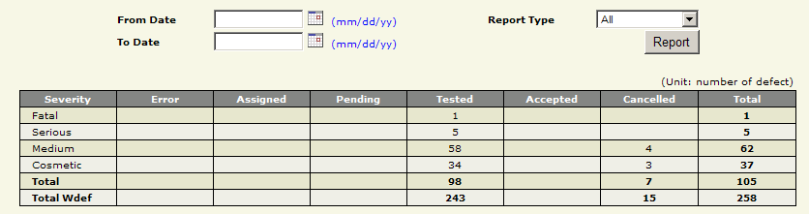

Defect Tracking
View defect summary by Work Product/Module & QC Activity
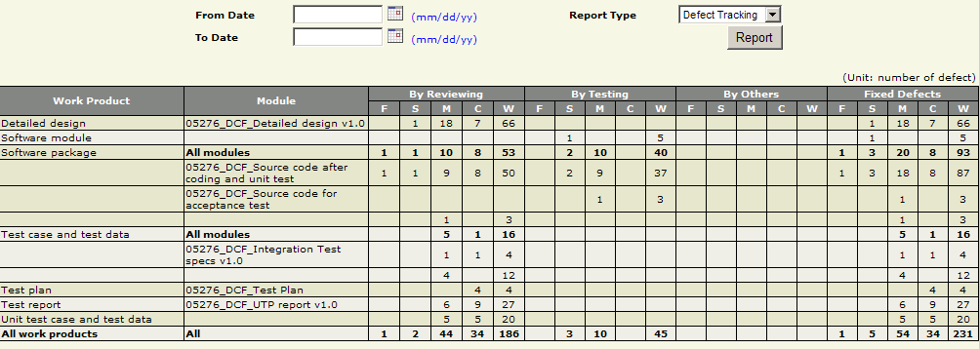

Defect Leakage
View project leakage summary by Work Product/Module.
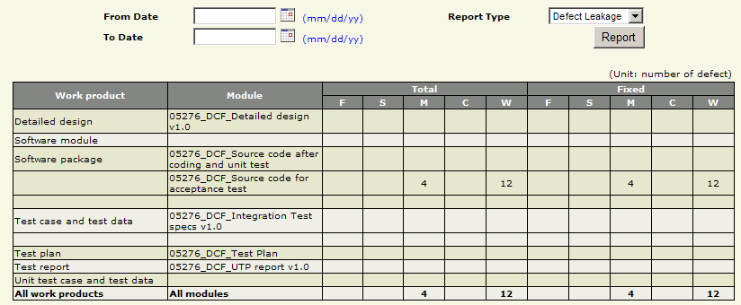

Defect Type
View defect summary by Defect Type & Severity.
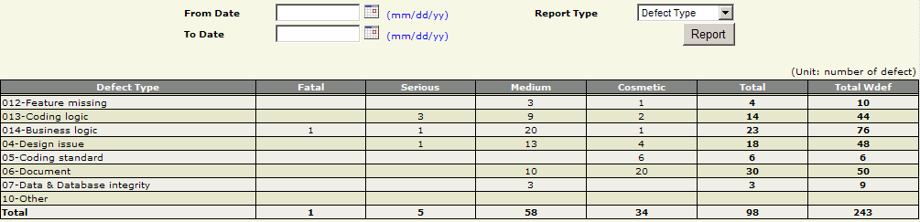

Defect Distribution
View defect summary by QC Activity & Process Injected.
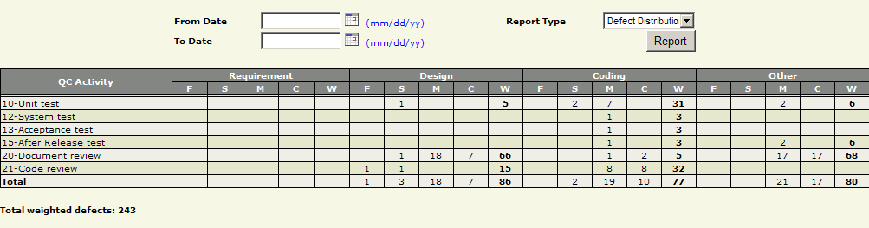

Defect Summary
View defect summary by Work Product/Module & detailed QC Activity.
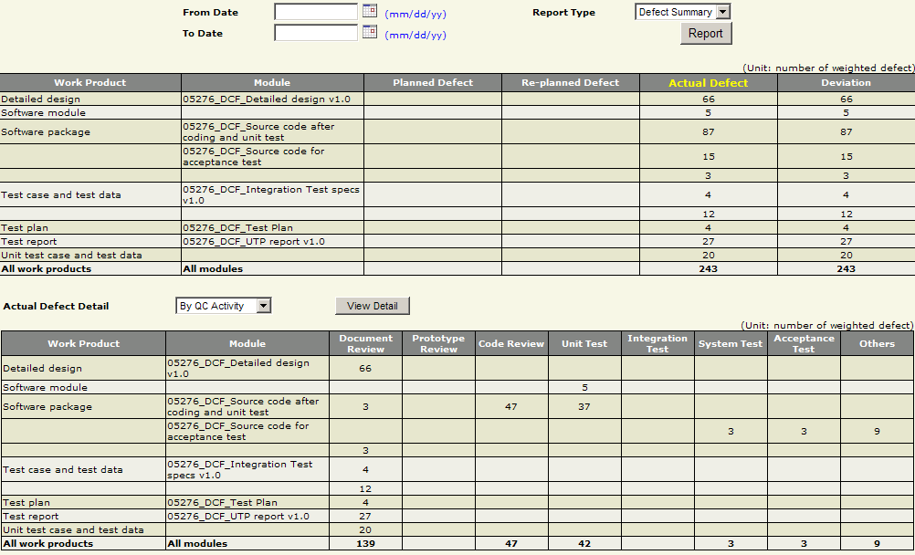
Another view is by Project Injected, which is similar to defect distribution view in Section 4.1.5

Defect related metrics
# | Name | Unit | Description
1 | Open defects | Def  (number of) | Number of actual open defects in DMS, counting defects with defect status = Error, Assigned or Pending.
2 | Open weighted defects | Wdef | Actual open defects in DMS but with weight for each Defect Severity, counting defects with defect status = Error, Assigned or Pending.
3 | Total defects | Def  (number of) | Number of actual defects in DMS, counting defects with all defect status except Cancelled.
4 | Total weighted defects | Wdef | Total actual defects in DMS but with weight for each Defect Severity, counting defects with all defect status except Cancelled.
5 | Defect rate | Wdef/UCP | Total actual weighted defects divided by actual project size (in UCP).
6 | Leakage | Wdef/UCP | Total actual leakage divided by actual project size (in UCP).
7 | Review effectiveness | Wdef/pd | Weighted defects found by review for each person-day.
8 | Test effectiveness | Wdef/pd | Weighted defects found by test for each person-day.
9 | Defect removal efficiency | % | Review efficiency + test efficiency
10 | Review efficiency | % | Percentage of weighted defects found by review on total weighted defects of project.
11 | Test efficiency | % | Percentage of weighted defects found by test on total weighted defects of project.
12 | Estimated defects | Wdef | Weighted defects planned to be found in a project.  Estimated defects = Estimated size in UCP x Defect rate of Norm
13 | Re-estimated defects | Wdef | Weighted defects planned to be found in a project after re-planning.  Re-estimated defects = Re-estimated size in UCP x Defect rate of Norm.
14 | To be removed defects | Wdef | (Re-)Estimated size x Defect rate of Norm – Planned leakage.
15 | Possible leakage | Wdef | Actual size((Re-)Estimated size) x Defect rate of Norm – (Total actual weighted defects – Total actual pending defects)
16 | Defect status  (Used in Fsoft Insight: weekly/milestone reports) | % | Planned weighted defects to be found/ Actual weighted defects found.

Approver | Reviewer | Creator
Nguyen Lam Phuong | Le The Hung | Nguyen Duy Binh

Appendix A – Defect logging for test projects

Action | Defect Description | QC Activity | Defect Origin | Work Product | Severity | Defect Type
Test case creation | Format, template (layout, version, record of change, spelling, etc.) | Document Review | Document Control | Test case & test data | Cosmetic | Document
Test case creation | Test case content (test condition, action, expected results, etc. is incorrect or lack) | Document Review | Requirement | Test case & test data | Medium | Requirement misunderstanding
Test case creation | Test case does not cover all situations (lack of test cases) | Document Review | Requirement | Test case & test data | Medium | Requirement misunderstanding/Feature missing
Test case creation | Redundant test cases (duplicate, incorrect test cases, etc.) | Document Review | Document Control | Test case & test data | Cosmetic | Document
Test data creation | Wrong test data (redundant, lack of test data or incorrect test data) | Document Review  /Other review | Requirement | Test case & test data | Medium | Requirement misunderstanding/Feature missing
Test scripts/test program | Errors found when reviewing test scripts | Code review | Test | Test script | Medium | Requirement misunderstanding
Test scripts/test program | Test scripts report wrong results | Document review | Test | Test script | Medium/Serious | Functionalities/  Requirement misunderstanding
Test execution | Test environment setup (incorrect OS, browser, locale, etc.) | Integration Test/  System Test/  Regression test | Test/Configuration management | Test report | Medium | Business logic/  Requirement misunderstanding
Test execution | Do not follow test case/test procedure | Integration Test/  System Test/  Regression test | Test | Test report | Medium | Requirement misunderstanding/Feature missing
Test execution | Do not use correct test input | Integration Test/  System Test/  Regression test | Test | Test report | Medium | Requirement misunderstanding
Test execution | Misunderstand expected results | Integration Test/  System Test/  Regression test | Test | Test report | Medium | Requirement misunderstanding
Test execution | Do no execute test case(s) | Integration Test/  System Test/  Regression test | Test | Test report | Serious | Feature missing
Test report | Format, template (layout, version, record of change, spelling, etc.) | Document Review | Document Control | Test report | Medium | Document
Test report | Test case is not executed/not passed but is reported as passed | Document Review | Test | Test report | Serious/  Medium | Document
Test report | Test cases are not N/A as reported | Document Review | Test | Test report | Medium | Document

